 | Appendix 10
 | Format for Mandatory Disclosure
 | Mandatory Disclosure | Updated on 19th April 2013
10.1 | AICTE File No. | Western/1-1437513202/2013/EOA
 | Date & Period of Last approval | 19th March 2013
10.2 | Name of the Institution | ASM’s Institute of International Business & Research
 | Address of the Institution | Survey No.29/1-2A,CTS No. 4695,C-Wing ,Old Pune-Mumbai Highway, Behind Sterling Honda Showroom , Pimpri, Pune-411018
 | City & Pin Code | PUNE – 411018
 | State/UT | MAHARASTRA STATE
 | Longitude & Latitude | 72 51\ 18 32 N
 | Phone Number with STD Code | 020-66351700
 | FAX Number with STD Code | 020-66351700
 | Office Hours at the Institution | 10.00 am-6.00 pm
 | Academic Hours at the Institution | 7.00 am-2.00 pm
 | Email | iibr@asmedu.org
 | Website | www.iibr.org
 | Nearest Railway Station (dist in Km) | Chinchwad,0.5 km
 | Nearest Airport (dist in Km) | LOHEGAON – 21 Kms
10.3 | Type of Institution | Private-Self Financed
 | Category(1) of the Institution | Non Minority
 | Category(2) of the Institution | Co-Ed
10.4 | Name of the organization running the Institute | AUDYOGIK SHIKSHAN MANDAL
 | Type of the organization | Society/Trust
 | Address of the organization | MIDC, BLOCK ‘C’ , CHINCHWAD
 |  | PUNE -19
 | Registered with | Charity commissioner
 | Registration Date | Society Reg. 25/03/83 Trust Reg. 18/05/83
 | Website of the Organization | www.asmedu.org
10.5 | Name of the affiliating University | NA
 | Address | NA
 | Website | NA
 | Last affiliation Period | NA
10.6 | Name of Principle/Director | Dr. K.C.Goyal
 | Exact Designation | Director
 | Phone Number with STD Code | 020-66351700
 | FAX Number with STD Code | 020-66351700
 | Email | iibr@asmedu.org
 | Highest Degree | Ph.D ,M.Com
 | Field of specialization | Business Administration
10.7 | Governing Board Members
 |  | - Mr. Surendra Kumar Jain
 |  | President MCCIA, Pune.
- Mr.Mukesh Malhotra
Managing Director Weikfield Products Co. (I) P. Ltd Ex-President ,MCCIA ,Pune
 |  | - Mr. Abhay Firodia
 |  | Chairman, Force Motots Ltd.& Ex-President ,MCCIA ,Pune
4) Prof. Dr. Sandeep R. Pachpande, B.E. (Computer), M.B.A.
(U.K.).,Chairman, Audyogik Shikshan Mandal
 |  | 5) Dr. (Mrs.) Asha Pachpande,Director,IBMR
 | Frequency of meeting & date of last meeting | Quarterly
10.8 | Academic Advisory Body | - Mr.Sudhnwa Kopardikar, MCCIA, Pune  - Prof. Dr. Sandeep R. Pachpande,,Chairman ASM  - Dr. (Mrs.) Asha Pachpande, Director, IBMR  - Prof.S.B.Mathur-Director General ,IIBR  - Ms Sunita Nikam-Associate Professor IIBR  - Mr Sudeep Limaye - Asst. Professor IIBR  - Dr.K.C.Goyal-Director, Member Secretary
 | Frequency of meeting & date of meeting | Quarterly
10.9 | Organizational Chart | 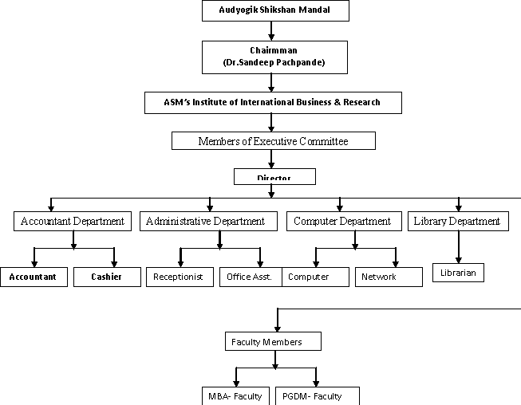
10.10 | Student Feedback mechanism on Institutional Governance / faculty performance | Students‟ evaluation of faculty feedback  Students‟ satisfaction feedback  Parents‟ feedback  Confidential Mapping of faculty by Management
10.11 | Grievance redressal mechanism for faculty , staff and students | Formation of Institute‟s Grievance Redressal Committee:  According to the AICTE‟s Establishment of Mechanism for Grievance Redressal, Regulation 2012, the Grievance Redressal Committee has been constituted with the objective of resolving the grievances of students, parents, and others. The updated committee comprises of following members:  Designation Name  Director of the institute Dr. K. C. Goyal  Co Coordinator Prof. Sudeep Limaye  Member Ms. Sunita Patil  All the aggrieved students, their parents and others may henceforth approach the Grievance Redressal Committee.
10.12 | Name of the Department* | Management-Approved By AICTE
 | Course | PGDM-BM,PGDM-BA
 | Level | Post Graduate
 | 1st Year of approval by the Council | Oct 2007
 | Year wise Sanctioned Intake | 2012-13  120 | 2011-12  120 | 2010-11  180
 | Year wise Actual Intake | 14 | 43 |  | 126
 | Cut off marks –General quota | 50% | 50% |  | 50%
 | % Student passed with Distinction | - | 44 % |  | 18 %
 | % Student passed with First Class | - | 43 % |  | 32 %
 | Students Placed | - | 85% |  | 98%
 | Average Pay package, Rs/Year | - | Rs.2.3 Lakhs |  | Rs.2.3 Lakhs
 | Student opted for Higher Studies | NOT APPLICABLE
10.12 | Name of the Department* | Management-Approved By AICTE & University of Pune
 | Course | MBA
 | Level | Post Graduate
 | 1st Year of approval by the Council | 2011
 | Year wise Sanctioned Intake | 2012-13  120 | 2011-12  120
 | Year wise Actual Intake | 102 | 114
 | Cut off marks –General quota | 50 % | 50 %
 | % Student passed with Distinction | NA | Result Awaited
 | % Student passed with First Class | NA | Result Awaited
 | Students Placed | NA | 65 %
 | Average Pay package, Rs/Year | NA | 2.8 Lakh
 | Student opted for Higher Studies | NOT APPLICABLE
 | Accreditation Status of the Course | NOT ELIGIBLE
 | Doctoral Course | NIL
 | Foreign Collaborations, if any | NOT APPLICABLE
 | Professional Society Membership | - MCCIA  - MEDC  - NIPM  - AIMA  - COME
 | Professional activities | - Leadership summit  - Mindscape(Case study presentation)  - Incon (International level research paper presentation)  - Bizz  - Educational Workshops  - Educational Seminars
 | Consultancy activities | NOT APPLICABLE
 | Grants Fetched | NOT APPLICABLE
 | Departmental Achievements | - Foreign Educational Tours, Visits of Foreign Faculty, Very good Co-curricular & extra curricular activities.  - Ranked among TOP 50 Best B-School in India
 | Distinguished Alumni | Name Of Alumni Designation Company Name  Mr.Kunal Kotecha Director Vnkc Agrocom Ptv.Ltd  Lakshmi Thimmaiah Deputy Manager- Honeywell TS  Vinay Pandey Regional Sales Manager(Western India) JAS Forwarding Worldwide  Mahendra Kumar Business Development Manager-India & Middle Ease Logwin Air + Ocean China Ltd.  Manas Pingle Senior Manager Univrsal Medicare  Sachin Tangri Manager-Export Marketing Bhansali Bright Bara Pvt.Ltd  Chinnappa C. Global Supply Chain Manager Monsanto India Ltd.  Kulshekhar General Manager S.J.Logistics(India ) Pvt.Ltd.

10.13 | Name of Teaching Staff | Dr. K. C. Goyal |  |  |  |  | 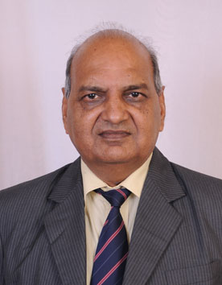
 | Designation | Director
 | Department | ASM’s IIBR-MBA
 | Date of Joining the Institution | 1st July,2011
 | Qualifications with Class/Grade | Ph.D.,M.Com.(Business Administration) , Ist Class.
 | Total Experience in Yrs | Teaching: - 38 Yrs | Industry: - Yrs |  |  |  | Research: Yrs 20
 | Papers Published | National: 02 |  |  | International: 1
 | Papers Presented in Conferences | National: 05 |  |  | International: 03
 | PhD Guide? Give Field & University | Field: Com. & Management |  |  | University: University of Kota (Raj.)
 | PhDs/Projects Guided | PhDs: 07 awarded and guiding to another 08 |  |  | Projects at Master Level: More than 30
 | Books Published/IPRs/Patents | 07 Books
 | Professional Memberships | Member of ISTD New Delhi
 | Consultancy Activities
 | Awards
 | Grants Fetched | Completed 03 MRP with UGC Financial grants
 | Interaction with Professional Institutions

10.13 | Name of Teaching Staff | Dr.S.B.Mathur |  |  |  |  | 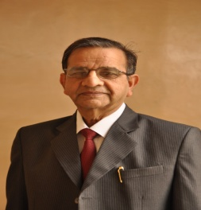
 | Designation | Director General ,Professor
 | Department | ASM’s IIBR-PGDM
 | Date of Joining the Institution | 1/09/07
 | Qualifications with Class/Grade | Ph.D.MPM(1st Class)
 | Total Experience in Yrs | Teaching: 10 Yrs |  | Industry: 35 Yr |  |  | Research: 5 Yrs.
 | Papers Published | National: 3 |  |  | International: 1
 | Papers Presented in Conferences | National :2 |  |  | International: 1
 | PhD Guide? Give Field & University | FieldL: - |  |  | University: -
 | PhDs/Projects Guided | PhDs: - |  |  | Projects at Master Level: 30
 | Books Published/IPRs/Patents | NIL
 | Professional Memberships | Fellow Institute of Engineers, Charted Engineers
 | Consultancy Activities | NIL
 | Awards | NIL
 | Grants Fetched | NIL
 | Interaction with Professional Institutions | Closely associated with MCCIA

 | Name of Teaching Staff | Dr.Dilip D.Ambarkhane |  |  | 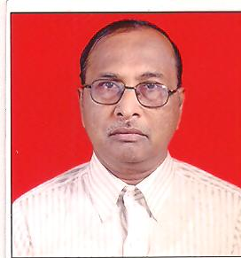
 | Designation | Dean ,Professor
 | Department | ASM’s IIBR-MBA
 | Date of Joining the Institution | 7th August 2012
 | Qualifications with Class/Grade | Ph.D ,M.Sc,MBA .with First Class
 | Total Experience in Yrs | Teaching: - 3 Yrs | Industry: -36 Yrs |  | Research: 3 Yrs
 | Papers Published | National: 2 |  | International: 2
 | Papers Presented in Conferences | National: 2 |  | International: 2
 | PhD Guide? Give Field & University | Field: - |  | University: -
 | PhDs/Projects Guided | PhDs: - |  | Projects at Master Level: 17
 | Books Published/IPRs/Patents | NIL
 | Professional Memberships | NIL
 | Consultancy Activities | NIL
 | Awards | IIT Silver Medal
 | Grants Fetched | NIL
 | Interaction with Professional Institutions | NIL

 | Name of Teaching Staff | Prof.Sunita Nikam |  |  |  |  | 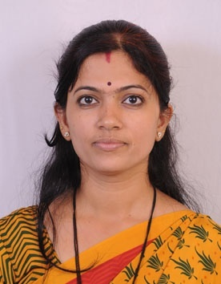
 | Designation | Associate Professor
 | Department | ASM’s IIBR-PGDM
 | Date of Joining the Institution | 16/07/ 2006
 | Qualifications with Class/Grade | M.Phil(CS),M.C.S.(First Class),B.C.S(First Class)
 | Total Experience in Yrs | Teaching: -8 Yrs | Industry: - Yrs |  |  |  | Research:1 Yrs
 | Papers Published | National: NIL |  |  |  | International: 1
 | Papers Presented in Conferences | National: 1 |  |  |  | International: 4
 | PhD Guide? Give Field & University | Field: NIL |  |  |  | University: NIL
 | PhDs/Projects Guided | PhDs: NIL |  |  |  | Projects at Master Level: 12
 | Books Published/IPRs/Patents | NIL
 | Professional Memberships | NIL
 | Consultancy Activities | NIL
 | Awards | FDP Certificate and National & International Seminar Certificate.
 | Grants Fetched | NIL
 | Interaction with Professional Institutions | NIL

 | Name of Teaching Staff | Prof.Abhijit Parchure |  |  | 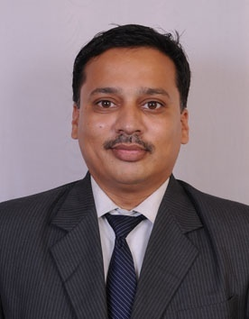
 | Designation | Associate Professor
 | Department | ASM’s IIBR-PGDM
 | Date of Joining the Institution | 01/08/2008
 | Qualifications with Class/Grade | M.A(Second Class),MS(UK)- M.S 3.4/ 4 GPA
 | Total Experience in Yrs | Teaching: -5 Yrs | Industry: - 3.9 Yrs |  | Research:- Yrs
 | Papers Published | National: NIL |  | International: 1
 | Papers Presented in Conferences | National: NIL |  | International: 1
 | PhD Guide? Give Field & University | Field :NIL |  | University :NIL
 | PhDs/Projects Guided | PhDs: NIL |  | Projects at Master Level: 10
 | Books Published/IPRs/Patents | NIL
 | Professional Memberships | NIL
 | Consultancy Activities | NIL
 | Awards | NIL
 | Grants Fetched | NIL
 | Interaction with Professional Institutions | NIL

 | Name of Teaching Staff | Prof.Anjali Khushwah |  |  |  |  | 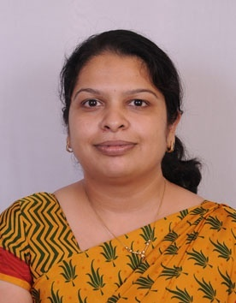
 | Designation | Associate Professor
 | Department | ASM’s IIBR-MBA
 | Date of Joining the Institution | 15/12/2009
 | Qualifications with Class/Grade | PGDBA,B.Com
 | Total Experience in Yrs | Teaching: -- 7 Yrs | Industry: - 3 Yrs |  |  |  | Research:- Yrs
 | Papers Published | National: NIL |  |  |  | International: 1
 | Papers Presented in Conferences | National: NIL |  |  |  | International: 1
 | PhD Guide? Give Field & University | Field: NIL |  |  |  | University: NIL
 | PhDs/Projects Guided | PhDs: NIL |  |  |  | Projects at Master Level: 22
 | Books Published/IPRs/Patents | NIL
 | Professional Memberships | NIL
 | Consultancy Activities | NIL
 | Awards | NIL
 | Grants Fetched | NIL
 | Interaction with Professional Institutions | NIL

 | Name of Teaching Staff | Prof.Ashutosh Belapure |  |  |  |  | 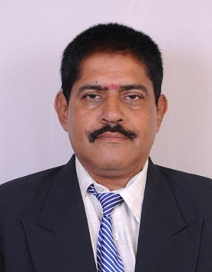
 | Designation | Asst. Professor
 | Department | ASM’s IIBR-PGDM
 | Date of Joining the Institution | 22/08/2011
 | Qualifications with Class/Grade | MDBA,BE,DCS,DIB,MIE(INDIA)
 | Total Experience in Yrs | Teaching: -3 Yrs | Industry: -27 Yrs |  |  |  | Research:-
 | Papers Published | National: 10 |  |  |  | International: NIL
 | Papers Presented in Conferences | National: 4 |  |  |  | International: 4
 | PhD Guide? Give Field & University | Field: NIL |  |  |  | University: NIL
 | PhDs/Projects Guided | PhDs :NIL |  |  |  | Projects at Master Level: 30
 | Books Published/IPRs/Patents | NIL
 | Professional Memberships | NIL
 | Consultancy Activities | NIL
 | Awards | NIL
 | Grants Fetched | NIL
 | Interaction with Professional Institutions | NIL

 | Name of Teaching Staff | Prof.Sudhir Kumar Singh |  |  | 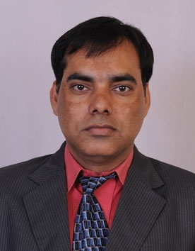
 | Designation | Asst. Professor
 | Department | ASM’s IIBR-MBA
 | Date of Joining the Institution | 01/08/2008
 | Qualifications with Class/Grade | MBA(Marketing & HR)-First Class,BA(Geo)
 | Total Experience in Yrs | Teaching: -4.6 Yrs | Industry: - 8.5 Yrs |  | Research:- Yrs
 | Papers Published | National: 1 |  | International: 5
 | Papers Presented in Conferences | National: 3 |  | International: 10
 | PhD Guide? Give Field & University | -  Field: - |  | University: -
 | PhDs/Projects Guided | PhDs: - |  | Projects at Master Level: 24
 | Books Published/IPRs/Patents | NIL
 | Professional Memberships | NIL
 | Consultancy Activities | NIL
 | Awards | Declared the Best performing sales manager twice in Ajanta Limited, and one time in Videocon Group
 | Grants Fetched | NIL
 | Interaction with Professional Institutions | NIL

 | Name of Teaching Staff | Prof.Sudeep Limaye |  |  | 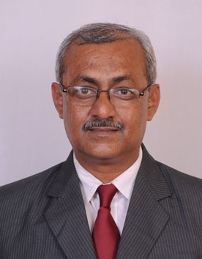
 | Designation | Asst. Professor
 | Department | ASM’s IIBR-MBA
 | Date of Joining the Institution | 19/06/2011
 | Qualifications with Class/Grade | M.COM, PGDBM,B.Com
 | Total Experience in Yrs | Teaching: -4.5 Yrs | Industry: -18 Yrs |  | Research:- Nil
 | Papers Published | National: 5 |  | International: 3
 | Papers Presented in Conferences | National: 7 |  | International: 3
 | PhD Guide? Give Field & University | -  Field: - |  | University: -
 | PhDs/Projects Guided | PhDs: -. |  | Projects at Master Level: 43
 | Books Published/IPRs/Patents | NIL
 | Professional Memberships | MCCIA,Pune
 | Consultancy Activities | NIL
 | Awards | Best Sales Person 1991
 | Grants Fetched | NIL
 | Interaction with Professional Institutions | NIL

 | Name of Teaching Staff | Prof.Shahana Khan |  |  | 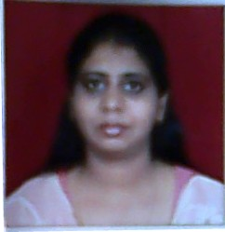
 | Designation | Asst. Professor
 | Department | ASM’s IIBR-PGDM
 | Date of Joining the Institution | 15/07/2008
 | Qualifications with Class/Grade | M.A. (Eco.)First Class B.Ed ,MBA,BA(Eco)
 | Total Experience in Yrs | Teaching: -7 Yrs | Industry: - 2 Yrs |  | Research:-1 Yrs
 | Papers Published | National: NIL |  | International: 2
 | Papers Presented in Conferences | National: 1 |  | International: 2
 | PhD Guide? Give Field & University | Field :- |  | University : -
 | PhDs/Projects Guided | PhDs: -. |  | Projects at Master Level: 15
 | Books Published/IPRs/Patents | NIL
 | Professional Memberships | NIL
 | Consultancy Activities | NIL
 | Awards | NIL
 | Grants Fetched | NIL
 | Interaction with Professional Institutions | NIL

 | Name of Teaching Staff | Prof.Rupali Pandya |  |  | 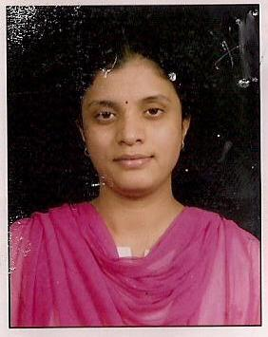
 | Designation | Asst. Professor
 | Department | ASM’s IIBR-MBA
 | Date of Joining the Institution | 15/01/2010
 | Qualifications with Class/Grade | M.Com,PGDBM(First Class)
 | Total Experience in Yrs | Teaching: - 1 Yrs | Industry: - 6 Yrs |  | Research:- 1 Yrs
 | Papers Published | National: NIL |  | International: NIL
 | Papers Presented in Conferences | National: NIL |  | International: NIL
 | PhD Guide? Give Field & University | Field :NIL |  | University: NIL
 | PhDs/Projects Guided | PhDs: NIL |  | Projects at Master Level: 12
 | Books Published/IPRs/Patents
 | Professional Memberships | Insurance Regulatory Development Authority
 | Consultancy Activities | NIL
 | Awards | NIL
 | Grants Fetched | NIL
 | Interaction with Professional Institutions | NIL

 | Name of Teaching Staff | Prof.Deepashree Nalawade |  |  | 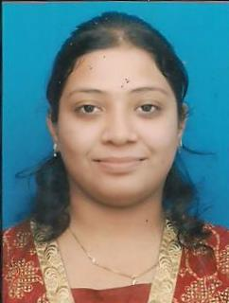
 | Designation | Asst. Professor
 | Department | ASM’s IIBR-PGDM
 | Date of Joining the Institution | 2/8/2010
 | Qualifications with Class/Grade | MBA(First Class),B.Sc.(Agree)(First Class)
 | Total Experience in Yrs | Teaching: -- 2 Yrs | Industry: - Yrs |  | Research:- Yrs
 | Papers Published | National: NIL |  | International: NIL
 | Papers Presented in Conferences | National: NIL |  | International: NIL
 | PhD Guide? Give Field & University | Field: NIL |  | University: NIL
 | PhDs/Projects Guided | PhDs: NIL |  | Projects at Master Level: 9
 | Books Published/IPRs/Patents | NIL
 | Professional Memberships | NIL
 | Consultancy Activities | NIL
 | Awards
 | Grants Fetched | NIL
 | Interaction with Professional Institutions | NIL

 | Name of Teaching Staff | Prof.Vinayak Gramopadhye |  |  | 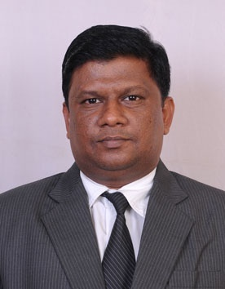
 | Designation | Asst. Professor
 | Department | ASM’s IIBR-MBA
 | Date of Joining the Institution | 2/8/2010
 | Qualifications with Class/Grade | MPM(First Class),BCOM.(First Class),MA
 | Total Experience in Yrs | Teaching: -- 2.6 Yrs | Industry: -4 Yrs |  | Research:- Yrs
 | Papers Published | National: NIL |  | International: NIL
 | Papers Presented in Conferences | National: NIL |  | International: NIL
 | PhD Guide? Give Field & University | Field: NIL |  | University: NIL
 | PhDs/Projects Guided | PhDs: NIL |  | Projects at Master Level: 33
 | Books Published/IPRs/Patents | NIL
 | Professional Memberships | NIL
 | Consultancy Activities | NIL
 | Awards
 | Grants Fetched | NIL
 | Interaction with Professional Institutions | NIL

 | Name of Teaching Staff | Prof.Sangita Slonake |  |  | 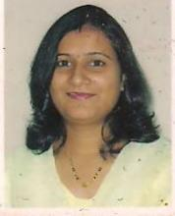
 | Designation | Asst. Professor
 | Department | ASM’s IIBR-PGDM
 | Date of Joining the Institution | 2/8/2010
 | Qualifications with Class/Grade | MBA(First Class),B.com.(First Class)
 | Total Experience in Yrs | Teaching: -- 2 Yrs | Industry: -1 Yrs |  | Research:- Yrs
 | Papers Published | National: NIL |  | International: NIL
 | Papers Presented in Conferences | National: NIL |  | International: NIL
 | PhD Guide? Give Field & University | Field: NIL |  | University: NIL
 | PhDs/Projects Guided | PhDs: NIL |  | Projects at Master Level: 2
 | Books Published/IPRs/Patents | NIL
 | Professional Memberships | NIL
 | Consultancy Activities | NIL
 | Awards
 | Grants Fetched | NIL
 | Interaction with Professional Institutions | NIL

 | Name of Teaching Staff | Prof.Shivaji Dhang |  |  | 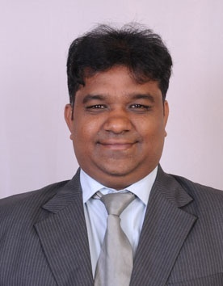
 | Designation | Asst. Professor
 | Department | ASM’s IIBR-PGDM
 | Date of Joining the Institution | 2/8/2010
 | Qualifications with Class/Grade | PGDBM(First Class),BCOM.(First Class)
 | Total Experience in Yrs | Teaching: -- 2 Yrs | Industry: -12 Yrs |  | Research:- Yrs
 | Papers Published | National: NIL |  | International: 1
 | Papers Presented in Conferences | National: NIL |  | International: 1
 | PhD Guide? Give Field & University | Field: NIL |  | University: NIL
 | PhDs/Projects Guided | PhDs: NIL |  | Projects at Master Level: 8
 | Books Published/IPRs/Patents | NIL
 | Professional Memberships | NIL
 | Consultancy Activities | NIL
 | Awards
 | Grants Fetched | NIL
 | Interaction with Professional Institutions | NIL

 | Name of Teaching Staff | Prof.Ranijt More |  |  | 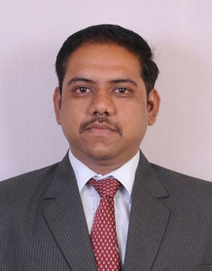
 | Designation | Asst. Professor
 | Department | ASM’s IIBR-MBA
 | Date of Joining the Institution | 2/8/2010
 | Qualifications with Class/Grade | MBA(First Class),BE.(First Class)
 | Total Experience in Yrs | Teaching: -- 2.6 Yrs | Industry: - Yrs |  | Research:- Yrs
 | Papers Published | National: NIL |  | International: 1
 | Papers Presented in Conferences | National: NIL |  | International: 2
 | PhD Guide? Give Field & University | Field: NIL |  | University: NIL
 | PhDs/Projects Guided | PhDs: NIL |  | Projects at Master Level: 15
 | Books Published/IPRs/Patents | NIL
 | Professional Memberships | NIL
 | Consultancy Activities | NIL
 | Awards
 | Grants Fetched | NIL
 | Interaction with Professional Institutions | NIL

 | Name of Teaching Staff | Prof.Minakshi Singh |  |  | 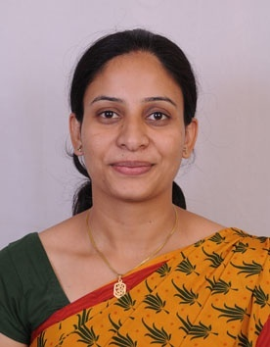
 | Designation | Asst. Professor
 | Department | ASM’s IIBR-MBA
 | Date of Joining the Institution | 2/8/2010
 | Qualifications with Class/Grade | MBE(First Class),BA-Honr.(First Class)
 | Total Experience in Yrs | Teaching: -- 4 Yrs | Industry: -6 Yrs |  | Research:- Yrs
 | Papers Published | National: NIL |  | International: 2
 | Papers Presented in Conferences | National: NIL |  | International: 2
 | PhD Guide? Give Field & University | Field: NIL |  | University: NIL
 | PhDs/Projects Guided | PhDs: NIL |  | Projects at Master Level: 8
 | Books Published/IPRs/Patents | NIL
 | Professional Memberships | NIL
 | Consultancy Activities | NIL
 | Awards
 | Grants Fetched | NIL
 | Interaction with Professional Institutions | NIL

 | Name of Teaching Staff | Prof.Simpy Bhat |  |  | 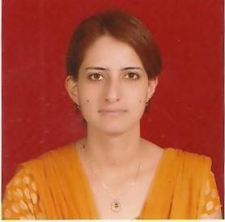
 | Designation | Asst. Professor
 | Department | ASM’s IIBR-MBA
 | Date of Joining the Institution | 2/8/2010
 | Qualifications with Class/Grade | MBA(First Class),BSc-Biotechnology (First Class)
 | Total Experience in Yrs | Teaching: -- 2.6 Yrs | Industry: -2 Yrs |  | Research:- Yrs
 | Papers Published | National: NIL |  | International: 1
 | Papers Presented in Conferences | National: NIL |  | International: 1
 | PhD Guide? Give Field & University | Field: NIL |  | University: NIL
 | PhDs/Projects Guided | PhDs: NIL |  | Projects at Master Level: 9
 | Books Published/IPRs/Patents | NIL
 | Professional Memberships | NIL
 | Consultancy Activities | NIL
 | Awards
 | Grants Fetched | NIL
 | Interaction with Professional Institutions | NIL

 | Name of Teaching Staff | Prof.Sweta Siddharth |  |  |  |  | 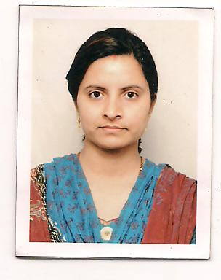
 | Designation | Asst. Professor
 | Department | ASM’s IIBR-PGDM
 | Date of Joining the Institution | 10/12/2011
 | Qualifications with Class/Grade | MBA,BE
 | Total Experience in Yrs | Teaching: - 2 Yrs | Industry: - 4 Yrs |  |  |  | Research:- Yrs
 | Papers Published | National: NIL |  |  |  | International: NIL
 | Papers Presented in Conferences | National: NIL |  |  |  | International: NIL
 | PhD Guide? Give Field & University | Field: NIL |  |  |  | University: NIL
 | PhDs/Projects Guided | PhDs: NIL |  |  |  | Projects at Master Level: 5
 | Books Published/IPRs/Patents | NIL
 | Professional Memberships | NIL
 | Consultancy Activities | NIL
 | Awards
 | Grants Fetched | NIL
 | Interaction with Professional Institutions | NIL

 | Name of Teaching Staff | Prof.Radha Mahatme |  |  |  |  | 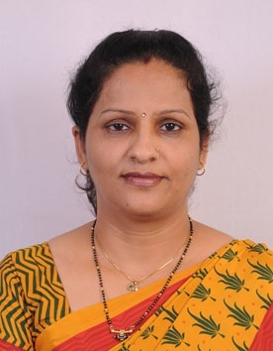
 | Designation | Asst. Professor
 | Department | ASM’s IIBR-MBA
 | Date of Joining the Institution | 15/12/2011
 | Qualifications with Class/Grade | MBA,M.Phil,MMM,M.com,CA(Inter)
 | Total Experience in Yrs | Teaching: - 5.6 Yrs | Industry: - Yrs |  |  |  | Research:- 1 Yrs
 | Papers Published | National: NIL |  |  |  | International: 2
 | Papers Presented in Conferences | National: NIL |  |  |  | International: 2
 | PhD Guide? Give Field & University | Field: NIL |  |  |  | University: NIL
 | PhDs/Projects Guided | PhDs: NIL |  |  |  | Projects at Master Level: 6
 | Books Published/IPRs/Patents | NIL
 | Professional Memberships | NIL
 | Consultancy Activities | NIL
 | Awards
 | Grants Fetched | NIL
 | Interaction with Professional Institutions | NIL

 | Name of Teaching Staff | Shivanand Sanmath |  |  | 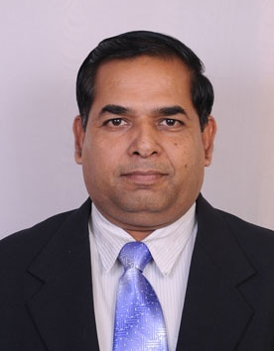
 | Designation | Asst Professor
 | Department | ASM’s IIBR-MBA
 | Date of Joining the Institution | 22/08/2011
 | Qualifications with Class/Grade | MMS-First, MCom & LLB-second
 | Total Experience in Yrs | Teaching: - 8 Yrs | Industry: - 22 Yrs |  | Research: Yrs
 | Papers Published | National: NiL |  | International: 2
 | Papers Presented in Conferences | National: Nil |  | International: 2
 | PhD Guide? Give Field & University | Field: - |  | University, -
 | PhDs/Projects Guided | PhDs: - |  | Projects at Master Level: 17
 | Books Published/IPRs/Patents | 02 syllabus books for YCMOU, Nasik(Basic of Accounting, Accounting to the Managers)
 | Professional Memberships | Active member of Baramati Sahakari Bank, Pune  Moderator & Paper Setter at YCMOU, Nashik (Period last 5 years)
 | Consultancy Activities | NIL
 | Awards | Recipient of AOC-in C commendation award on 26th Jan 1991.
 | Grants Fetched | NIL
 | Interaction with Professional Institutions | All over India & Nepal 17 edu fair attended

 | Name of Teaching Staff | Nivedita S Naikpawar |  |  | 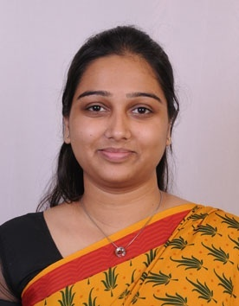
 | Designation | Asst Professor
 | Department | ASM’s IIBR-MBA
 | Date of Joining the Institution | 22 Aug’11
 | Qualifications with Class/Grade | B.com- I class, MMM- I class
 | Total Experience in Yrs | Teaching: - 1 Year | Industry: - 1Yr |  | Research: Yrs
 | Papers Published | National: nil |  | International: 1
 | Papers Presented in Conferences | National: nil |  | International: 1
 | PhD Guide? Give Field & University | Field: N/A |  | University: N/A
 | PhDs/Projects Guided | PhDs: N/A |  | Projects at Master Level: 6
 | Books Published/IPRs/Patents | Nil
 | Professional Memberships | Nil
 | Consultancy Activities | Nil
 | Awards | Nil
 | Grants Fetched | Nil
 | Interaction with Professional Institutions | Nil

 | Name of Teaching Staff | Sachin Ashok Ambekar |  |  | 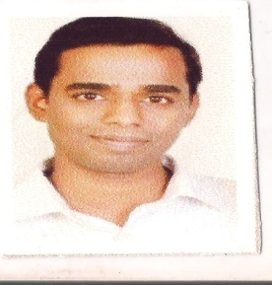
 | Designation | Assistant Professor
 | Department | ASM’s IIBR-MBA
 | Date of Joining the Institution | 1st September 2011
 | Qualifications with Class/Grade | B.COM,MBA(HR & Mkt) with First Class
 | Total Experience in Yrs | Teaching: - 1.7 Yrs | Industry: -10 Yrs |  | Research: 0Yrs
 | Papers Published | National: NIL |  | International: 2
 | Papers Presented in Conferences | National: NIL |  | International: 2
 | PhD Guide? Give Field & University | Field: - |  | University: -
 | PhDs/Projects Guided | PhDs: - |  | Projects at Master Level: 8
 | Books Published/IPRs/Patents | NIL
 | Professional Memberships | NIL
 | Consultancy Activities | NIL
 | Awards | NIL
 | Grants Fetched | NIL
 | Interaction with Professional Institutions | NIL

 | Name of Teaching Staff | Mansi Diwekar |  |  | 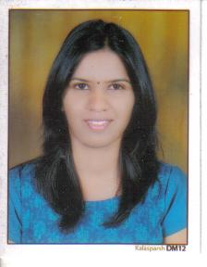
 | Designation | Assistant Professor
 | Department | ASM’s IIBR-MBA
 | Date of Joining the Institution | 2nd July 2012
 | Qualifications with Class/Grade | MMM with First Class, B.Sc.(Agree),
 | Total Experience in Yrs | Teaching: - 6 Months | Industry: -1 Yrs |  | Research: 0 Yrs
 | Papers Published | National: NI |  | International: 1
 | Papers Presented in Conferences | National: NIL |  | International: 1
 | PhD Guide? Give Field & University | Field: NIL |  | University: NIL
 | PhDs/Projects Guided | PhDs: NIL |  | Projects at Master Level: 2
 | Books Published/IPRs/Patents | NIL
 | Professional Memberships | NIL
 | Consultancy Activities | NIL
 | Awards | NIL
 | Grants Fetched | NIL
 | Interaction with Professional Institutions | NIL

 | Name of Teaching Staff | Sameer Kumar |  |  | 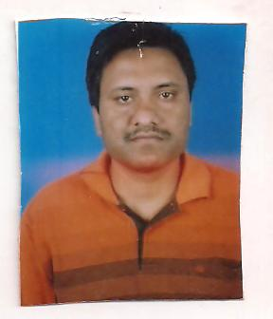
 | Designation | Assistant Professor
 | Department | ASM’s IIBR-PGDM
 | Date of Joining the Institution | 27th August 2012
 | Qualifications with Class/Grade | NET-June 2012,PGDBM with First Class, B.Sc(Math),
 | Total Experience in Yrs | Teaching: - 0.6 Yrs | Industry: - 4 Yrs |  | Research: 0 Yrs
 | Papers Published | National: NIL |  | International:
 | Papers Presented in Conferences | National: NIL |  | International:
 | PhD Guide? Give Field & University | Field: NIL |  | University:
 | PhDs/Projects Guided | PhDs: |  | Projects at Master Level: 2
 | Books Published/IPRs/Patents | NIL
 | Professional Memberships | NIL
 | Consultancy Activities | NIL
 | Awards | NIL
 | Grants Fetched | NIL
 | Interaction with Professional Institutions | NIL

 | Name of Teaching Staff | Madhuri Choudhari |  |  |  |  | 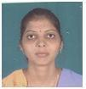
 | Designation | Assistant Professor
 | Department | ASM’s IIBR-PGDM
 | Date of Joining the Institution | August 2012
 | Qualifications with Class/Grade | MBS,PGDBM,MCM,BCS
 | Total Experience in Yrs | Teaching: - 6 Yrs | Industry: - Yrs |  |  |  | Research: 0 Yrs
 | Papers Published | National: NIL |  |  |  | International: 3
 | Papers Presented in Conferences | National: NIL |  |  |  | International: 3
 | PhD Guide? Give Field & University | Field: - |  |  |  | University: -
 | PhDs/Projects Guided | PhDs: -. |  |  |  | Projects at Master Level: 3
 | Books Published/IPRs/Patents | NIL
 | Professional Memberships | NIL
 | Consultancy Activities | NIL
 | Awards | NIL
 | Grants Fetched | NIL
 | Interaction with Professional Institutions | NIL

 | Name of Teaching Staff | Punita Ladwani |  |  |  |  | 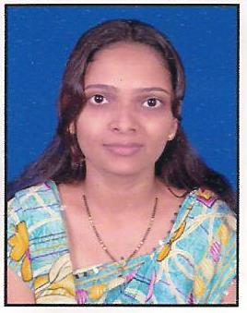
 | Designation | Assistant Professor
 | Department | ASM’s IIBR-PGDM
 | Date of Joining the Institution | 17th December 2012
 | Qualifications with Class/Grade | MPM,PGDBM,B.Com
 | Total Experience in Yrs | Teaching: - 2 Yrs | Industry: - 2 Yrs |  |  |  | Research: 0 Yrs
 | Papers Published | National: NIL |  |  |  | International: 1
 | Papers Presented in Conferences | National: NIL |  |  |  | International: 1
 | PhD Guide? Give Field & University | Field: |  |  |  | University:
 | PhDs/Projects Guided | PhDs: NIL |  |  |  | Projects at Master Level: 11
 | Books Published/IPRs/Patents | NIL
 | Professional Memberships | NIL
 | Consultancy Activities | NIL
 | Awards | NIL
 | Grants Fetched | NIL
 | Interaction with Professional Institutions | NIL

 | Name of Teaching Staff | Rajeshwar Hendre |  |  |  |  | 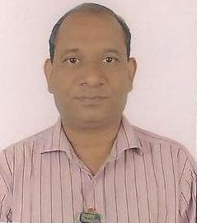
 | Designation | Assistant Professor
 | Department | ASM’s IIBR-PGDM
 | Date of Joining the Institution | 17th December 2012
 | Qualifications with Class/Grade | MBA,PGDOM,AMIE,DCE,DIS
 | Total Experience in Yrs | Teaching: - 1 Yrs | Industry: - 21 Yrs |  |  |  | Research: 0 Yrs
 | Papers Published | National: 4 |  |  |  | International: 4
 | Papers Presented in Conferences | National: 4 |  |  |  | International: 4
 | PhD Guide? Give Field & University | Field: |  |  |  | University:
 | PhDs/Projects Guided | PhDs: NIL |  |  |  | Projects at Master Level: 5
 | Books Published/IPRs/Patents | NIL
 | Professional Memberships | NIL
 | Consultancy Activities | NIL
 | Awards | NIL
 | Grants Fetched | NIL
 | Interaction with Professional Institutions | NIL

 | Name of Teaching Staff | Yogita Sutar |  |  |  |  | 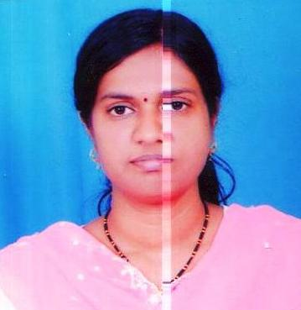
 | Designation | Assistant Professor
 | Department | ASM’s IIBR-PGDM
 | Date of Joining the Institution | 17th December 2012
 | Qualifications with Class/Grade | NET-2010,M.Com,PGDBM,B.Com
 | Total Experience in Yrs | Teaching: - 3 Yrs | Industry: - Yrs |  |  |  | Research: 0 Yrs
 | Papers Published | National: 1 |  |  |  | International: 1
 | Papers Presented in Conferences | National: 1 |  |  |  | International: 1
 | PhD Guide? Give Field & University | Field: |  |  |  | University:
 | PhDs/Projects Guided | PhDs: NIL |  |  |  | Projects at Master Level: 2
 | Books Published/IPRs/Patents | NIL
 | Professional Memberships | NIL
 | Consultancy Activities | NIL
 | Awards | NIL
 | Grants Fetched | NIL
 | Interaction with Professional Institutions | NIL

10.14 | Admission Quota* | Sanctioned Seat=120 seats(MBA),PGDM(BM)-60,PGDM(BA)-60  As per directives of AICTE and or DTE ,Maharashtra
 | Entrance test/admission criteria | CAT/MAT/ATMA/XAT etc… and AICTE/DTE ,Maharashtra
 | Cut off/last candidate admitted | Minimum Score -MATscore450  Maximum Score above MAT score450
 | Fees in rupees | Course MBA PGDM  2011-12 2012-13 2011-12 2012-13  Tuition Fees 63,000 68,040 97,000 97,000  Development Fees 6000 Nil Nil  Total Fees 63,000 74040 97,000 97,000
 | Number of Fee Waivers offered | For MBA through CAP of DTE Mumbai,  Maharashtra State reserved category students, as per Government  directives, applicable each year
 | Admission Calendar-PGDM | - As per notified by DTE, Maharashtra & AICTE.
 | Admission Calendar-MBA | (Schedule of activities As per Directorate of Technical Education  (DTE), Maharashtra)
 | PIO Quota | NOT APPLICABLE
10.15 | Infrastructural information
 | Classroom /Tutorial Room Facilities | 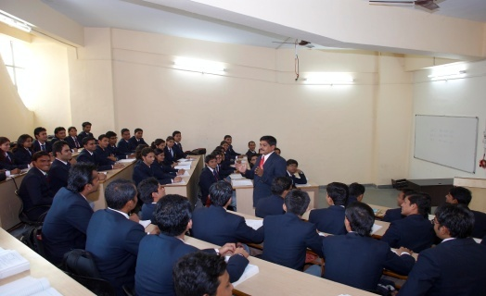 | 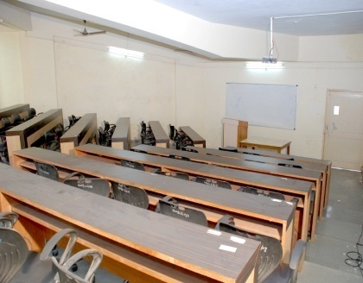
 | Computer Centre facilities | 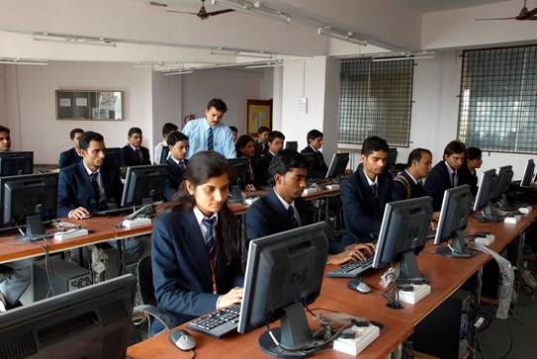 | 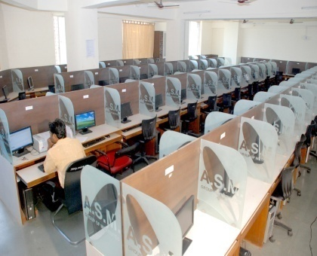
 | Library facilities | 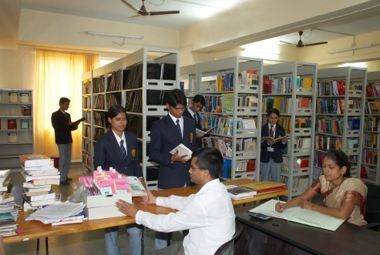 | 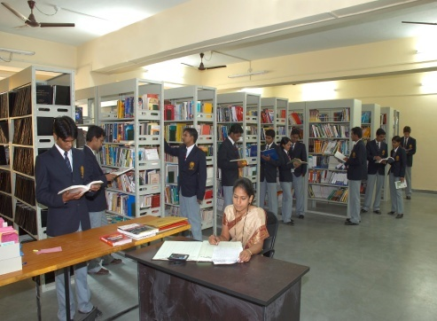
 | Auditorium/Seminar Halls/Amphi | 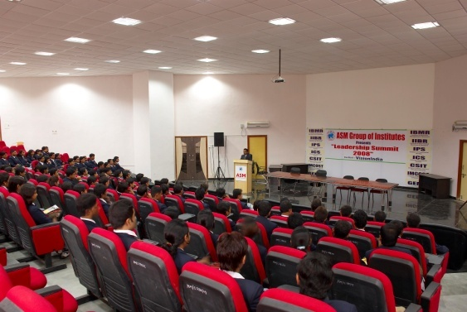 | 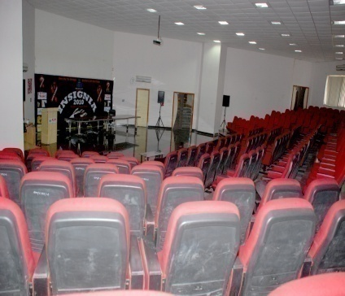
 | Cafeteria | 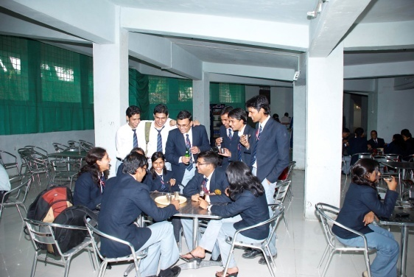 | 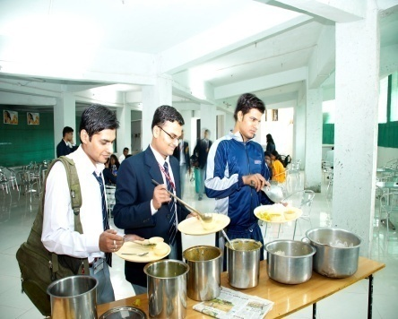
 | Indoor Sports facilities | 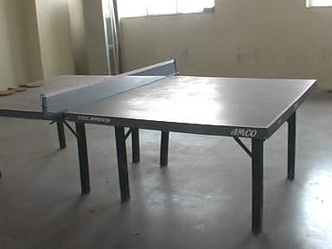 | 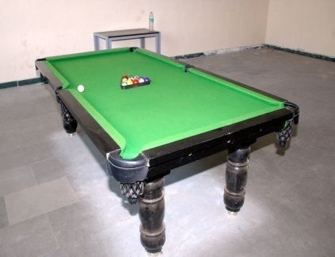
 | Outdoor Sports facilities | 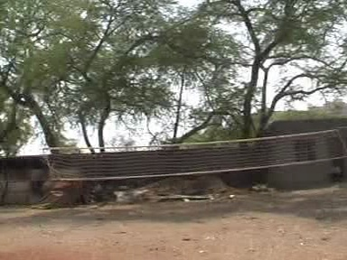
 | Gymnasium facilities | 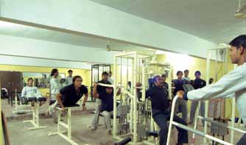
 | Any Other Facilities | 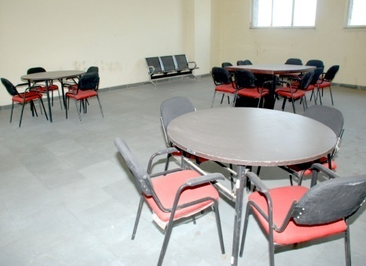 | 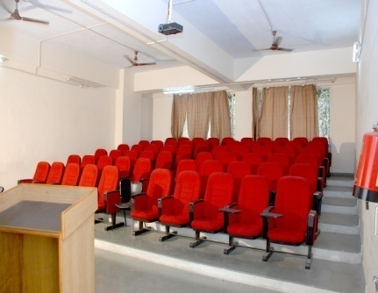
 | Hobby Club | 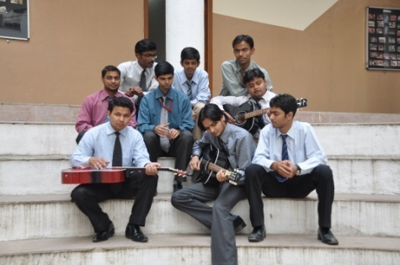 | 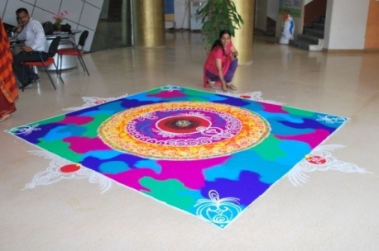
 | Medical/Water Facility | 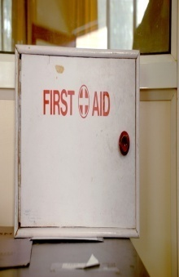 | 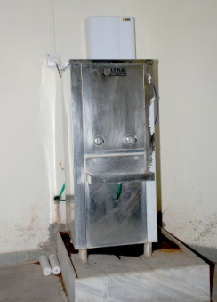
 |  | 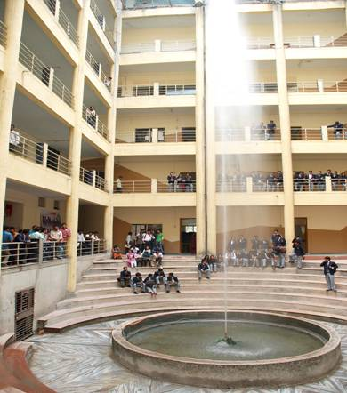
 | Facilities for disabled
 | Laboratory Details | NOT APPLICABLE
10.16 | Boys Hostel | NO
 | Girls Hostel | NO
 | Medical & Other facilities at Hostel | YES
10.17 | Academic Session | August to May every year-Semester Wise
 | Examination system. Year/Sem | Twice in the year -Semester Wise
 | Period of declaration of results | As per the Semester System 45 days from the completion of exam.
10.18 | Counseling / Mentoring | Counseling & Mentoring a group of students
 | Career Counseling | Through Placement cell
 | Medical facilities | 24 Hrs. Wellness Center & First aid facility including Stretcher & Wheel Chair in Institute.
 | Student Insurance | National Health Insurance Ltd.  Mediclaim Policy of Rs. 50,000/- per year  Traffic accident policy of Rs. 1,00,000/- per year  As per the University of Pune Medical Insurance Scheme
10.19 | Student Activity Body
 | Cultural Activities | INSIGNIA,INSIGN(Drawing Competition), Hobby classes Sports activities  Inter\ Intra College Competitions.
 | Sports Activities | Basket ball, Volley ball & Indoor games.  Inter/ Intra College Competitions, Handling own Sports club
 | Literary Activities | INCON, Workshops, MINDSCAPE,BIZZ, Seminars & Lectures by foreign  faculty Newspaper & Magazines to all students
 | Magazine / Newsletter | ASM Business Review ,ASM’s IIBR Newsletter
 | Technical Activities /TechFest | Soft skill development, Workshops, Seminars
 | Industrial Visits /Tours | - Industrial tour to Singapore,Thailand,Goa  - Volkswagen India Pvt Ltd Chakan Pune  - Thyssen Krupp Industries India, Pune  - Visit to Bombay Port  - Visites to Sandvik Asia ltd,  - Auto Cluster ltd, Praj Industries ltd.  - VolkWagen  - Mapro(Mahabaleshwar)  - Force Motors.  - Siddeshwar Ltd.
 | Alumni Activities | Alumni Meet
20. | Name of the Information officer for RTI | Mr. Shivaji Sawant
 | Designation | Accounts Officer
 | Phone Number with STD Code | 020-66351700
 | FAX Number with STD Code | 020-66351700
 | Email | iibr@asmedu.org

